Cost of attending  IMEX America 2024  as a hosted buyer | 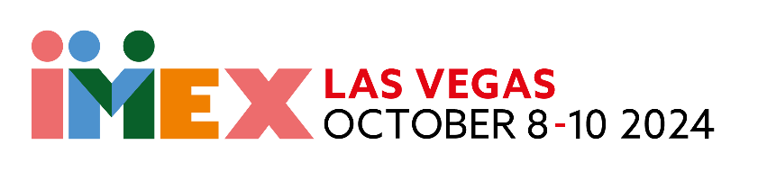
 |  | Cost
IMEX America registration | Registration is free | $ 0
Accommodations | I’ll stay at one of IMEX’s partner hotels in America (room only) for my hosted buyer program dates  I’ll only incur costs if I stay extra nights | $ 0  $ …………
Travel | IMEX will cover my travel to the show:  I’ll organize my own travel to America (by plane) and claim a reimbursement up to the value shown on the travel reimbursement limits table | $ 0
Ground transportation | Shuttle buses between the airport, hotel and the show are provided on show days | $ 0
Education sessions | There’s no charge for any of the 150+ education sessions on offer | $ 0
Meals | I’ll save by attending breakfast presentations, booth events, hosted buyer group evening functions and other networking events  I’ll take advantage of discounts provided by partner restaurants, and use the IMEX Hosted Buyer Lounge which offers complimentary refreshments | $ ………….
Visa application fees | Visa application fees charged by the US embassy (if applicable) | $ ………….
Travel insurance | Comprehensive travel insurance to cover my IMEX America trip | $ ………….
Personal extras | Additional expenses: telephone charges, Wi-Fi, newspaper, laundry service, etc. | $ ………….
TOTAL: $ ………….

